Opto-Isolated Input Board Assembly Instructions

Board Version 1.0, Dated 11/2021

Mike Hilton, Eckerd College

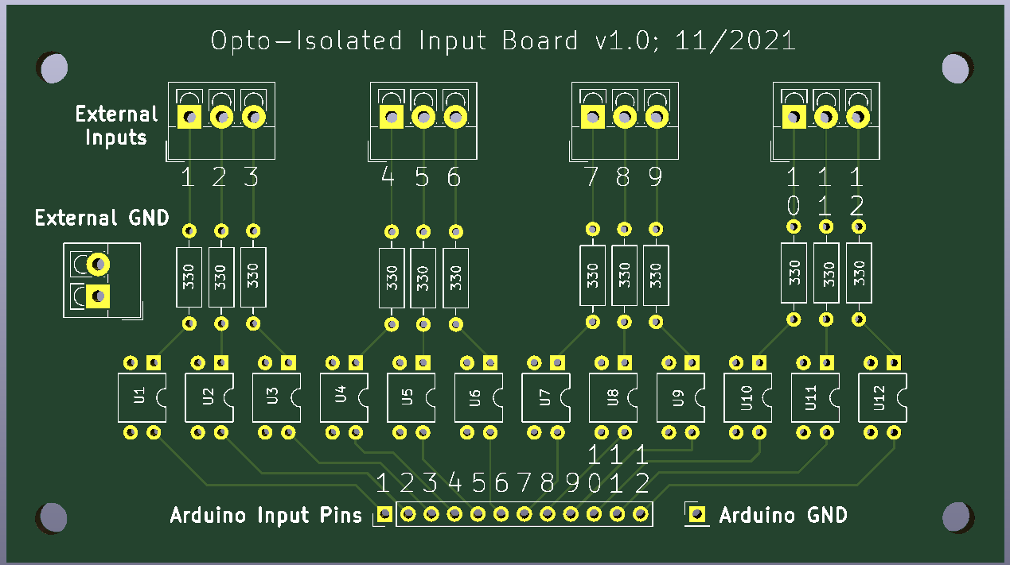

**Purpose**

The opto-isolated input board provides 12 channels of digital input that are electrically isolated from the Arduino. This protects the Arduino from voltage spikes that might be present in the input signals due to noise (such as the stray voltages induced by solenoids when they fire), or to be connected to circuits that use different voltage levels than the Arduino.

**Usage**

External inputs are connected to the three-input screw terminals along the top edge of the board. Each external input is connected via an opto-isolator chip to a corresponding header pin located along the bottom edge of the board for connection to the Arduino.

The external ground should be connected to the two-input screw terminal on the left edge of the board. The two ground terminals are electrically connected. Only a single ground wire is necessary; the other terminal can be used to provide external ground to other circuits.

**Parts List**

|  |  |
| --- | --- |
| *Quantity* | *Description* |
| 12 | 330 Ohm Resistors |
| 12 | PC817 Opto-isolator Chips |
| 4 | 3-Pin Screw Terminal Block Connector, 3.5mm Pitch (External Inputs) |
| 1 | 2-Pin Screw Terminal Block Connector, 3.5mm Pitch (External GND) |
| 1 | 12-Pin Header, 2.54mm Pitch (Arduino Header Pins) |
| 1 | 1-Pin Header, 2.54mm Pitch (Arduino GND) |

**Assembly**

1. Solder all the 330 Ohm resistors
2. Solder the PC817 opto-isolator chips in place. There is a small circle on the face of the chips to indicate pin 1, which should be oriented in the same direction as the semicircular cutout on each of the circuit board’s chip outlines.
3. Solder on the 3-pin screw terminals. The openings for the wires should face the top edge of the board.
4. Solder on the 2-pin screw terminal. The openings for the wires should face the left edge of the board.
5. Solder the Arduino header pins in place.

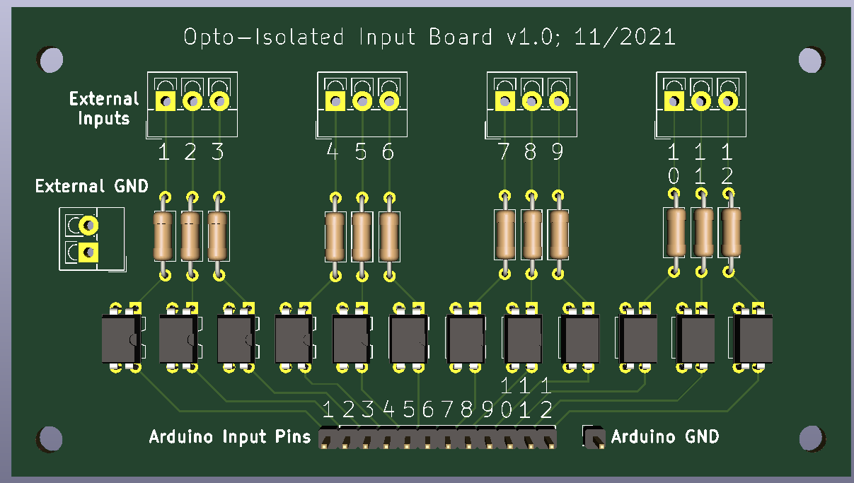

**Test Circuit**

Each input channel can be tested using a circuit like the one shown below, which is testing Input 1. If the channel is working properly, the LED will light up.

